# **ASSIGNMENT 1**

**Line Graph:**

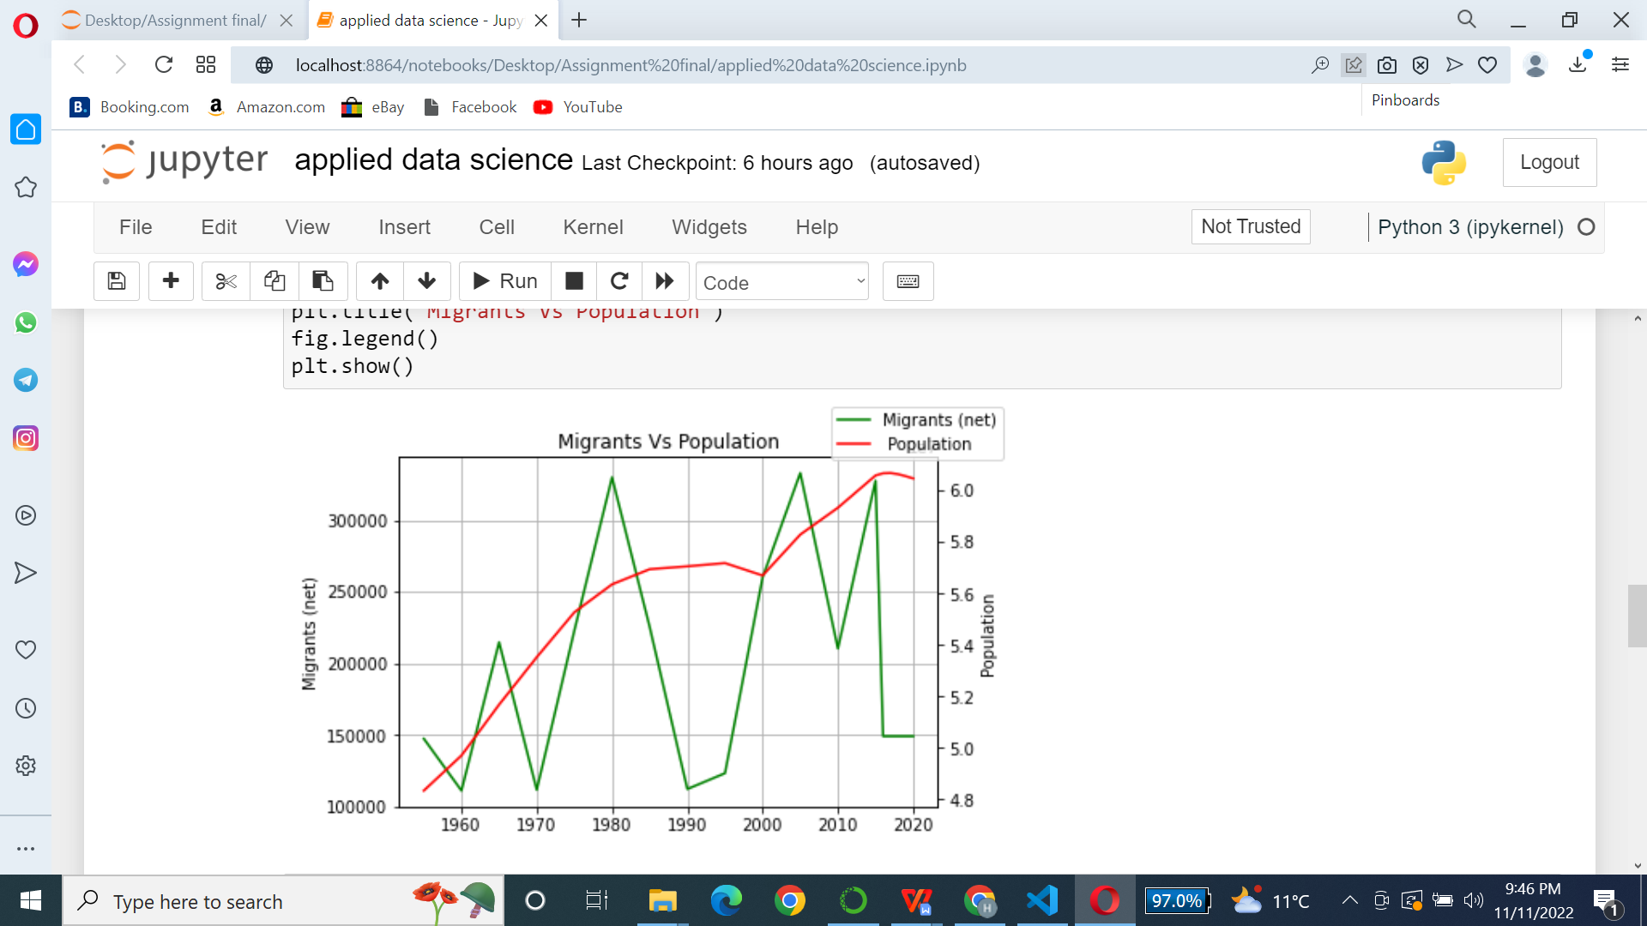

To monitor changes over both short and long time periods, line graphs are utilized. Line graphs perform better than bar graphs when there are smaller changes. Line graphs can be used to compare changes over time for various groups.

The above line chart shows migrants and population of Italy over the period of time. Population of this country continuously increases but the number of migrants shows fluctuation.

**Pie Chart:**

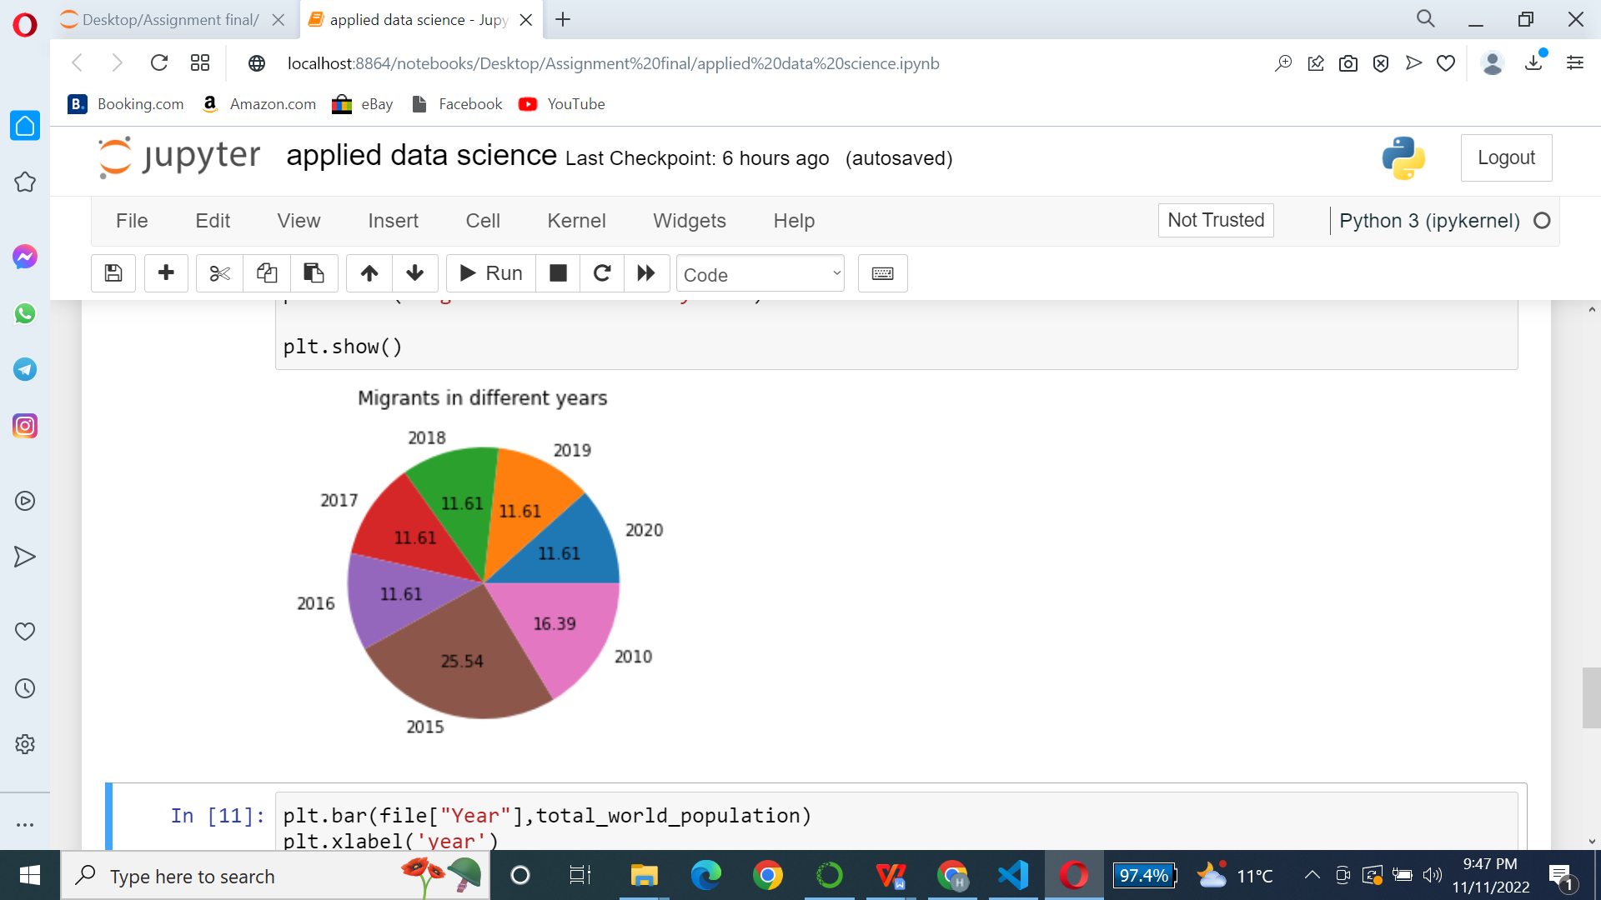

Pie charts are most likely the most effective type of visual for illustrating a part-to-whole relationship. One sign that a pie chart might be the right solution for you is when you hear "percent of..." or "part of..."

This pie chart shows how many migrants moves to Italy in different years.

**Bar Graph:**

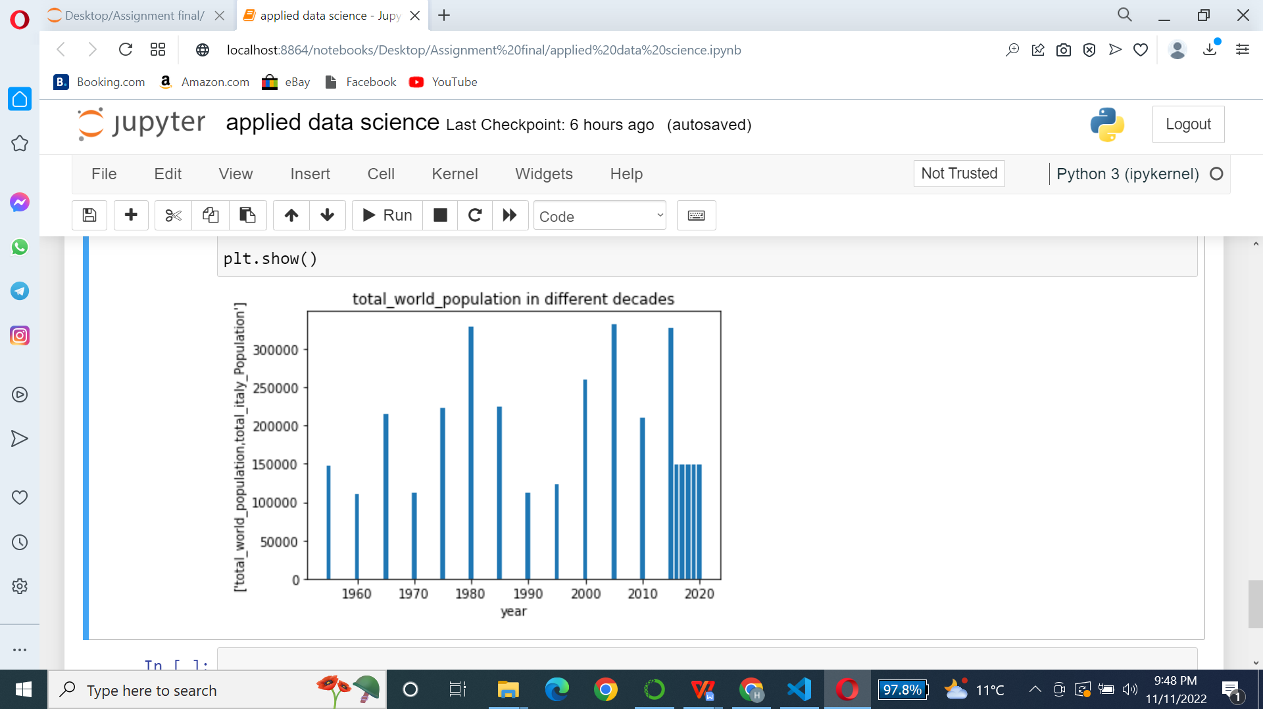

The bar graph makes it simple to compare various sets of data among various groups. The relationship is depicted using two axes, with the discrete values on one axis and the categories on the other. The graph displays the key alterations in the data over time.

This bar chart shows the population of Italy in different years.

**Link:** [https://www.kaggle.com/datasets/sandhyakrishnan02/italy-population-19552020](C:\\Users\\DELL\\Desktop\\Assignment final)